**Cairo University**

**Faculty of Computers and Artificial Intelligence**

**Software Engineering**

**Sent** to: Dr. Mohamed El-Ramly

CS251

* **Assignment: A1**
* **Task: T1 &T2**
* **Date: 2025/2/25**
* **Section: S14**
* **Team Programming Language: Java**
* **Team Leader Phone Number: +20 128 696 4627**
* **Name, IDs, and E-mails:**

|  |  |  |
| --- | --- | --- |
| Name | IDs | E-Mails. |
| Aly El-Deen Yasser Ali | 20231109 | ali.el.badry.747@gmail.com |
| Nagham Wael Mohamed | 20231189 | naghamw63@gmail.com |
| Fatema El-Zhraa Ahmed Mohamed El-Fiky | 20230280 | fatmaelfeky922@gmail.com |

Table of Content

**The Process of Learning 3**

Aly ElDeen Program3

Nagham Program 9

Fatema El-Zhraa Program 14

**Low Code No Code Tool22**

Evaluation for LCNC Tools22

The potential of LCNC Tools22

What LCNC Tools Can Do 23

Benefits of LCNC Tools23

Will LCNC Tools Take the Job of Developers? 24

**Compare between The two LCNC Tools25**

**Pre-Project Activities25**

Market and Gap analysis24

Globel Practice24

Egypt’s Market:24

Gap analysis24

Market Segmentation & Research24

Customer segmants24

Demographics24

**The Process of Learning :**

**Aly El-Deen Yasser Aly:**

* Hours of Study: 18 hours
* Source of study https://youtube.com/playlist?list=PLCInYL3l2AajYlZGzU_LVrHdoouf8W6ZN&si=tfRlF2iNxOtJehum
* Main Logic of code:
* import java.util.ArrayList;  
  import Workers.Manger.Manger;  
  import Workers.Normal.Junior.Junior;  
  import Workers.Normal.Normal;  
  import Workers.Normal.Senior.Senior;  
  import Board.Board;  
    
  public class Main {  
    
   public static void main(String[] args) {  
    
   // Initialize manager list and add a default manager  
   ArrayList<Manger> mangers = new ArrayList<>();  
   mangers.add(new Manger("Aly", 20000, "General", "aly", "11114"));  
    
   // Initialize lists for Juniors and Seniors  
   ArrayList<Junior> juniors = new ArrayList<>();  
   ArrayList<Senior> seniors = new ArrayList<>();  
    
   // Create the board with the existing worker lists  
   Board board = new Board(juniors, mangers, seniors);  
    
   // Main menu loop for user interaction  
   while (true) {  
   int menuChoice = Normal.*getValidChoice*(  
   new String[]{"Manager", "Senior", "Junior", "Exit"},  
   "# ==== Welcome to Workers Management System ==== #"  
   );  
    
   // Navigate based on user choice  
   if (menuChoice == 0)  
   board.manage();  
   else if (menuChoice == 1)  
   board.seniorWork();  
   else if (menuChoice == 2)  
   board.juniorWork();  
   else if (menuChoice == 3)  
   break;  
   }  
    
   System.*out*.println("\nThanks For Using Our Program");  
   }  
  }_____________________________________________________________________________
* 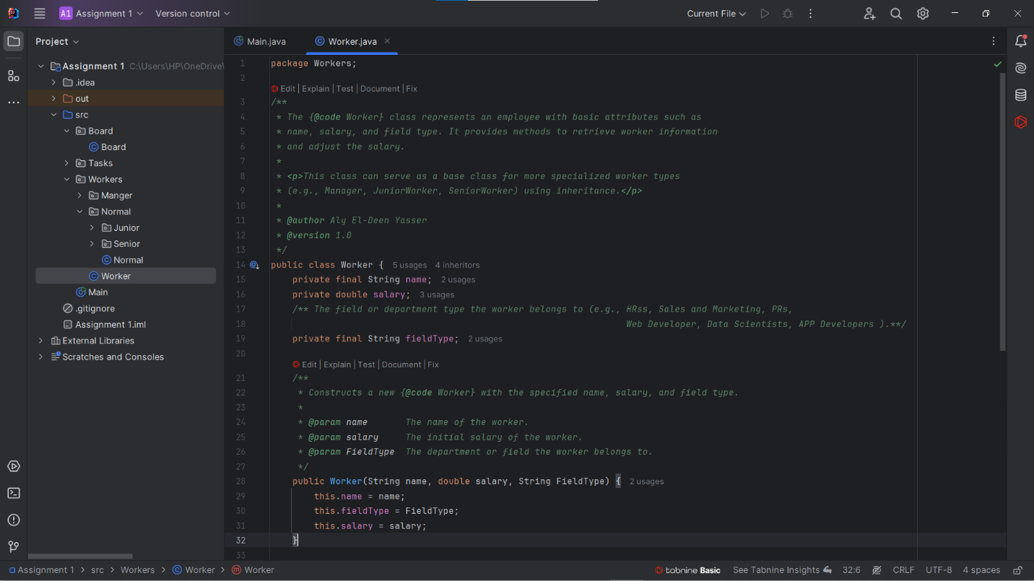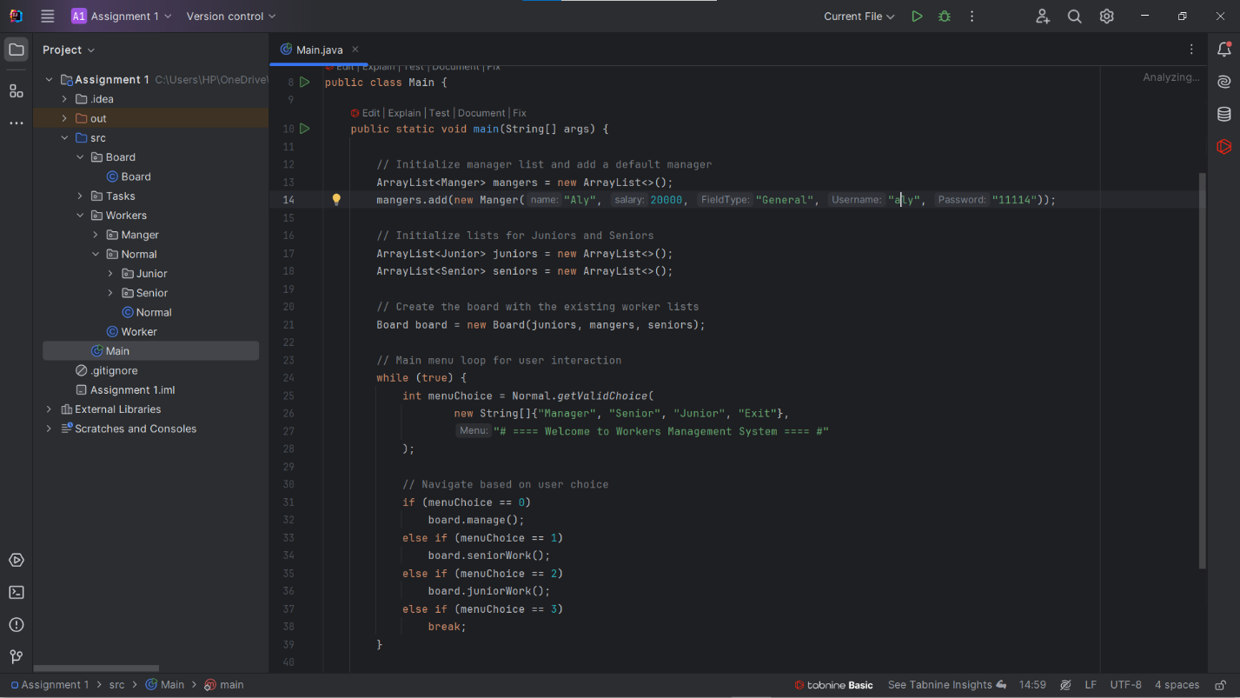Images For the code:

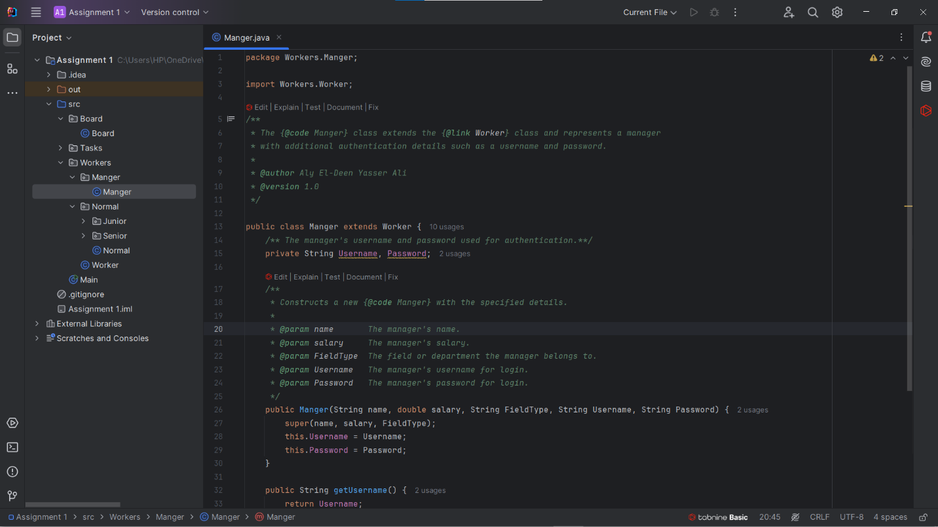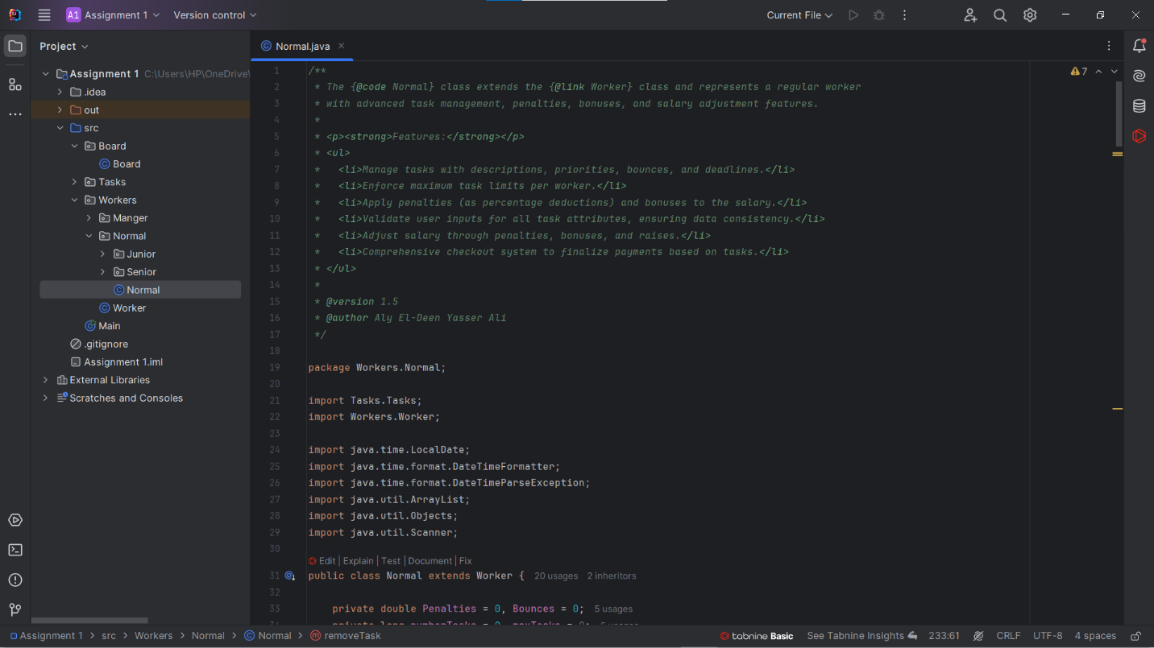

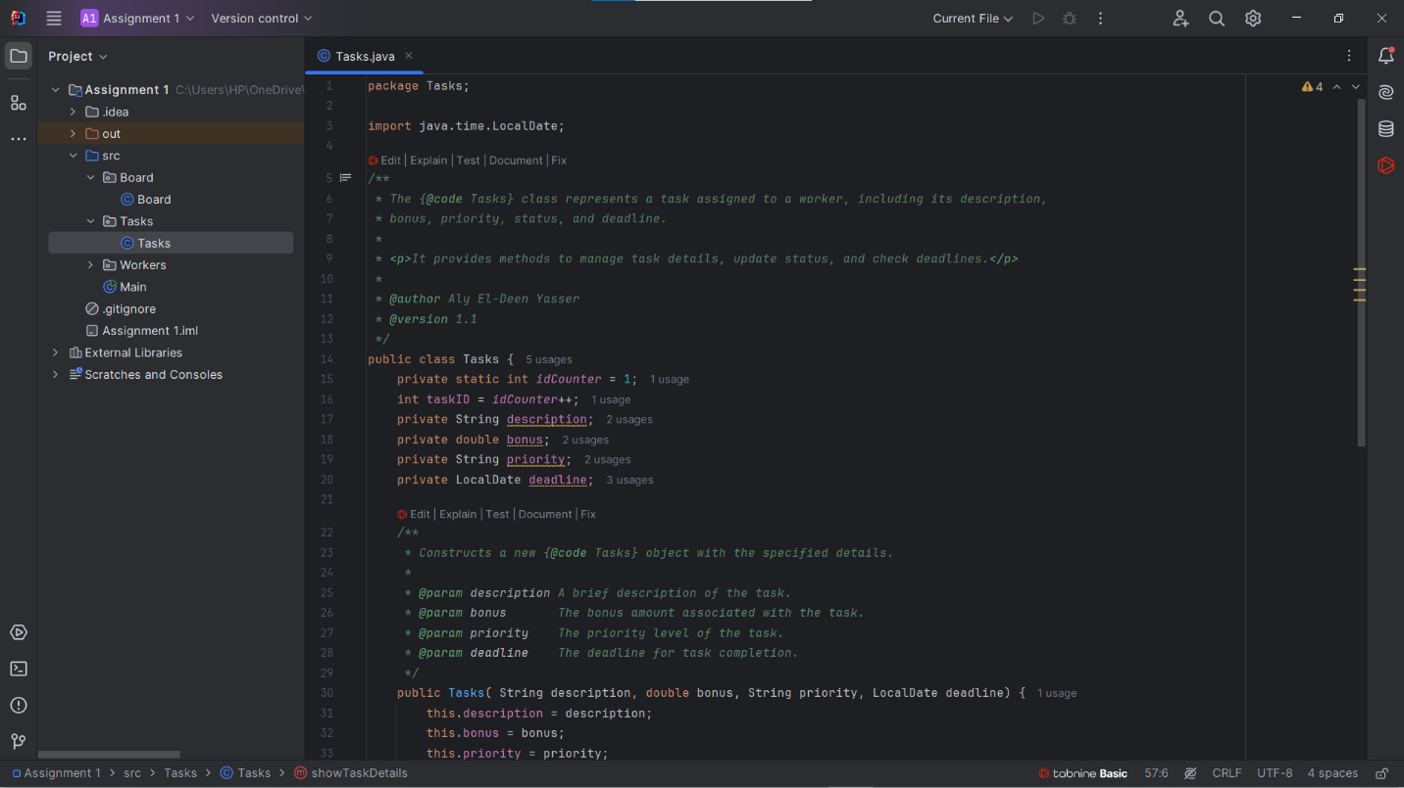

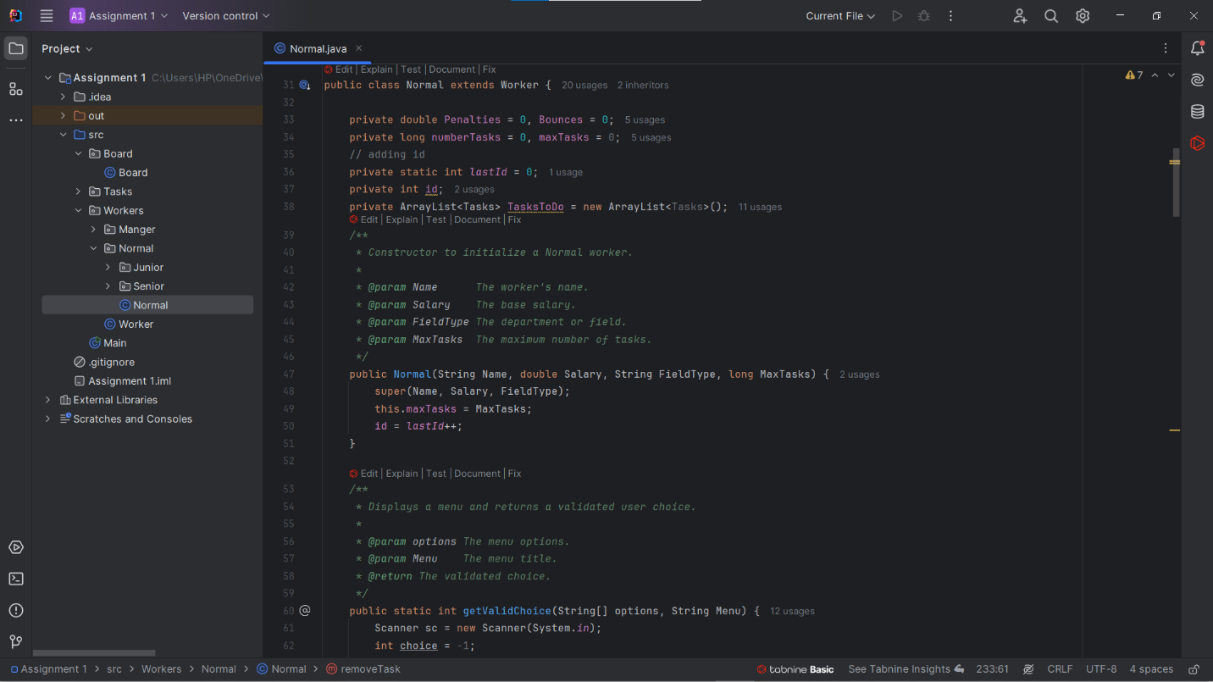

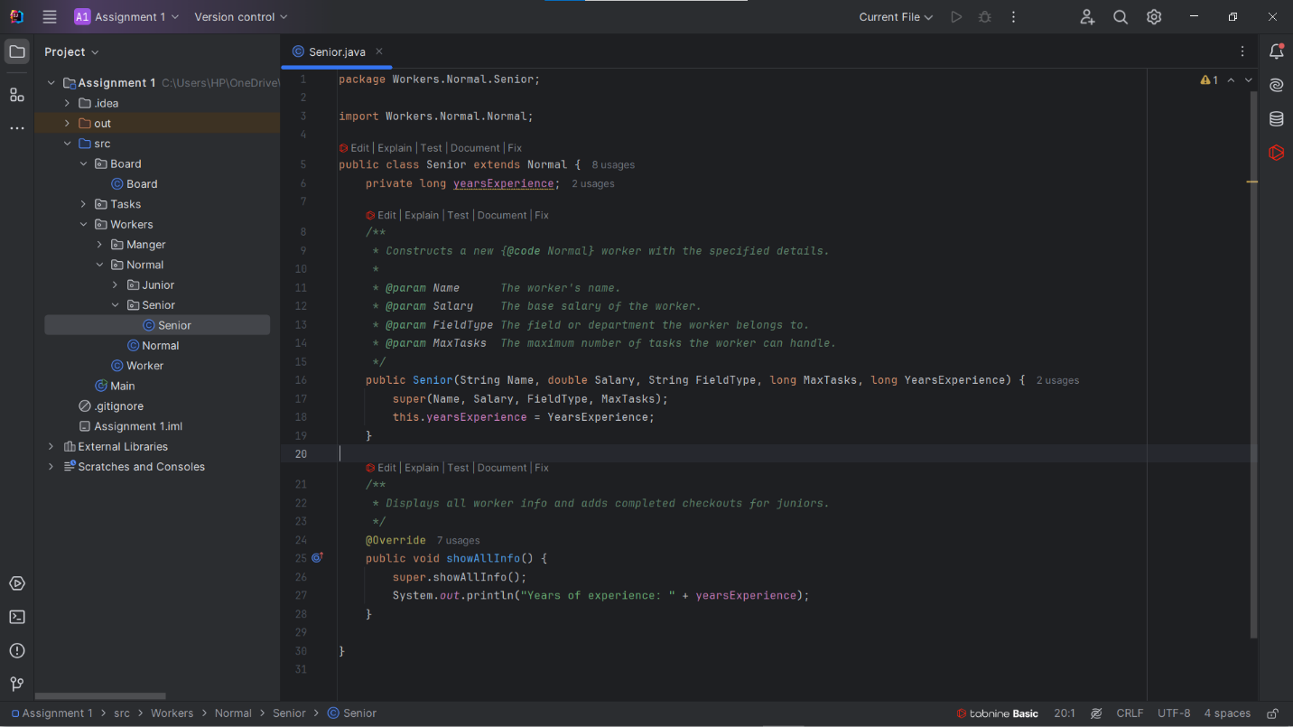

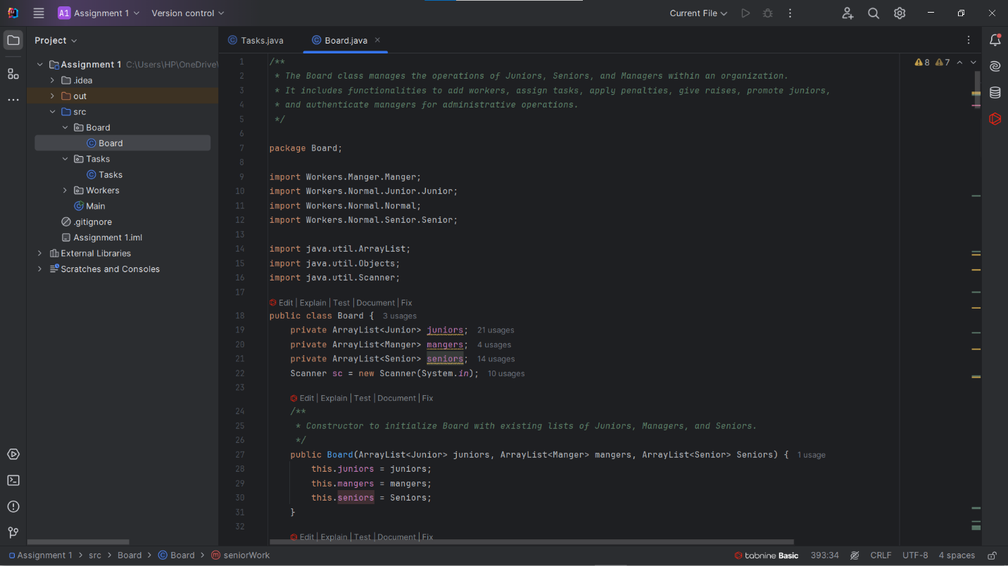

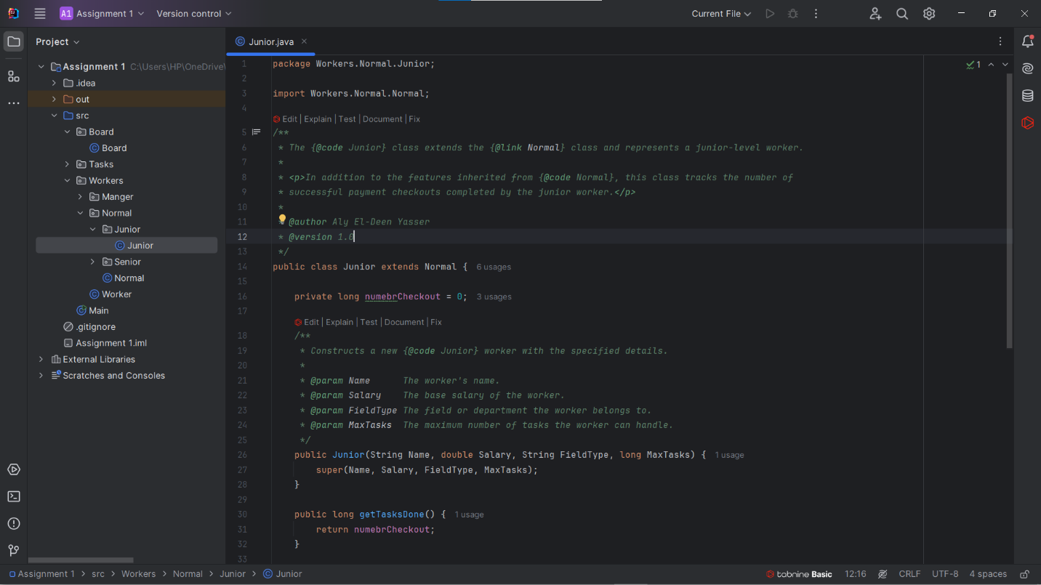

Video Link: https://youtu.be/-brwmS8jSZo

**Nagham Wael:**

* Hours of Study: 12h
* Source of Study: Geeks For Geeks + https://youtube.com/playlist?list=PLCInYL3l2AajYlZGzU_LVrHdoouf8W6ZN&si=tfRlF2iNxOtJehum
* Main Code Logic:
* public static void main(String[] args) {  
   boolean running = true;  
    
   //display menu while the program is running(user didn't choose exit)  
   while (running) {  
   printMenu();  
   String choice = scanner.nextLine().trim();  
   switch (choice) {  
   case "1":  
   addTask();  
   break;  
   case "2":  
   removeTask();  
   break;  
   case "3":  
   displayTaskDetails();  
   break;  
   case "4":  
   editTask();  
   break;  
   case "5":  
   sortTasks();  
   break;  
   case "6":  
   displayList();  
   break;  
   case "7":  
   clearList();  
   break;  
   case "8":  
   saveListToFile();  
   break;  
   case "9":  
   running = false;  
   System.out.println("Exiting program...");  
   break;  
   default:  
   System.out.println("Invalid option. Please choose from 1 to 9.");  
   }  
   }  
    
   scanner.close();  
  }

________________________________________________________________________

* Images for code :

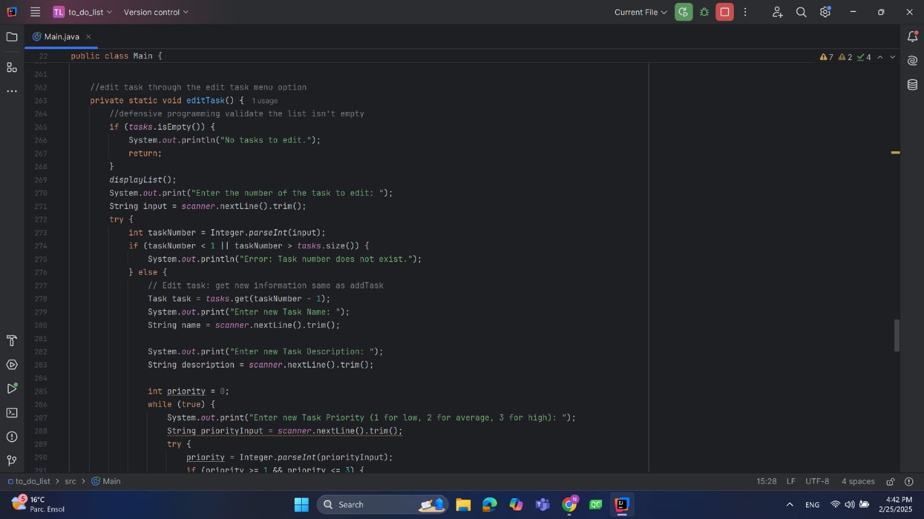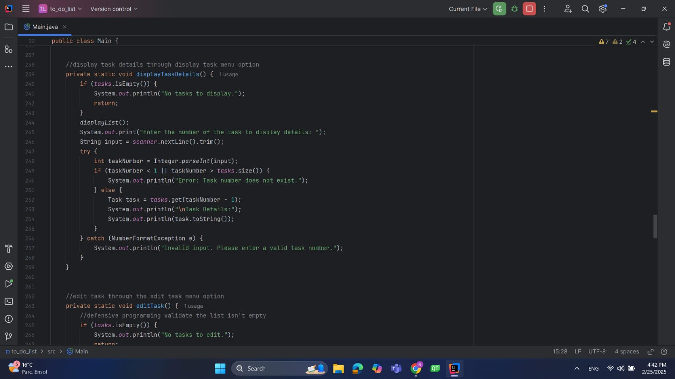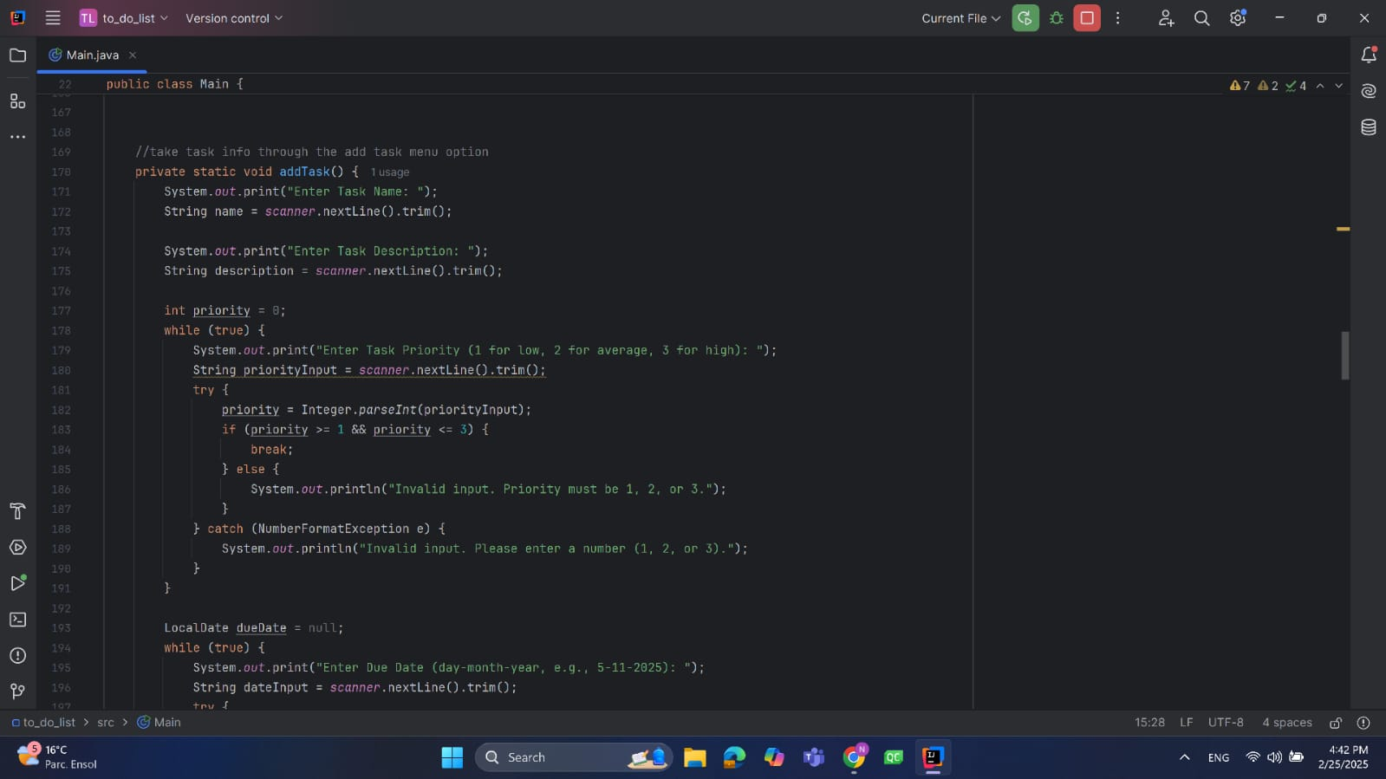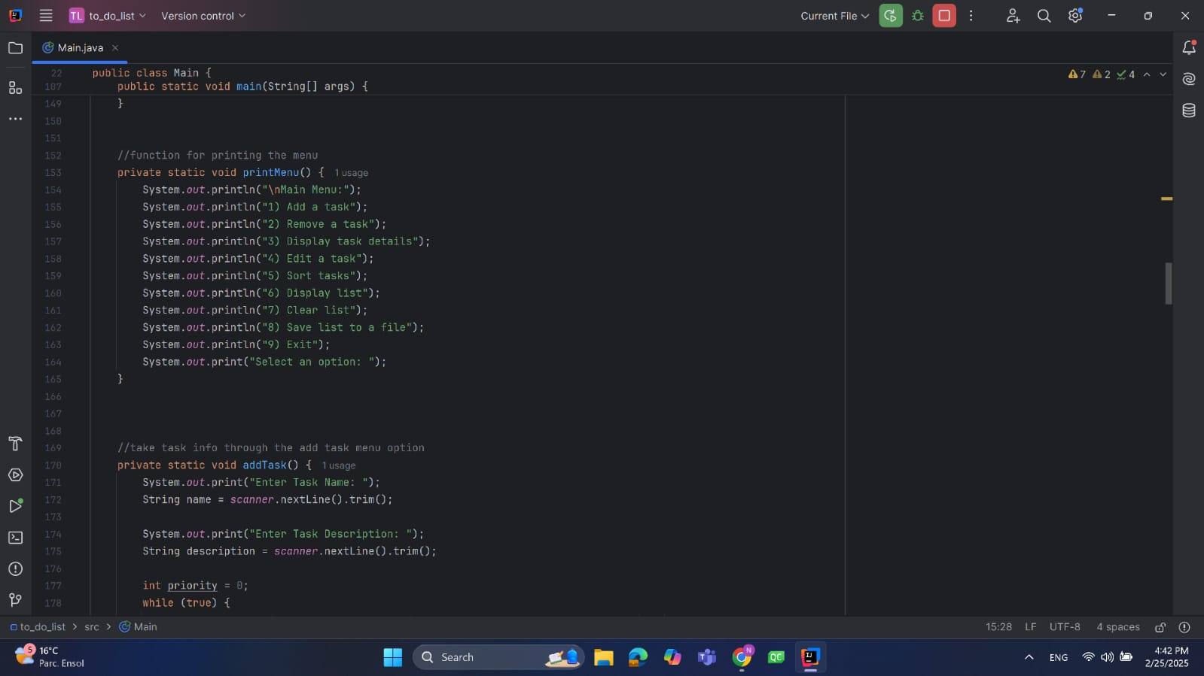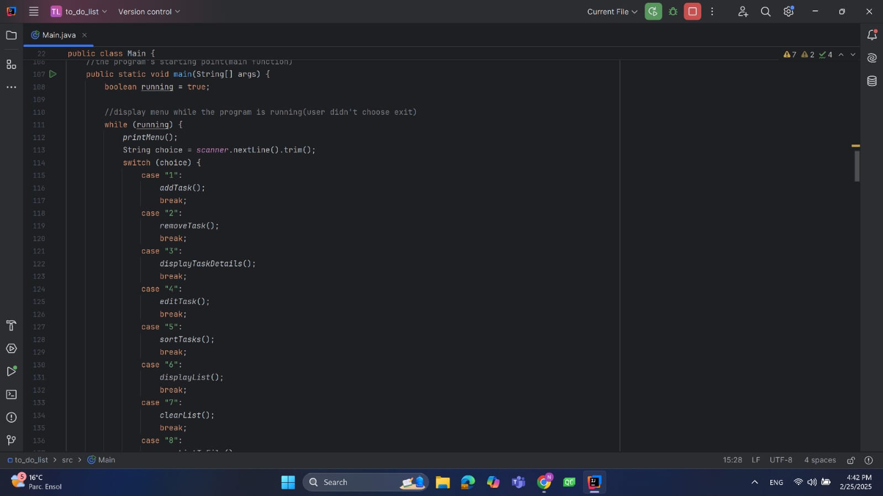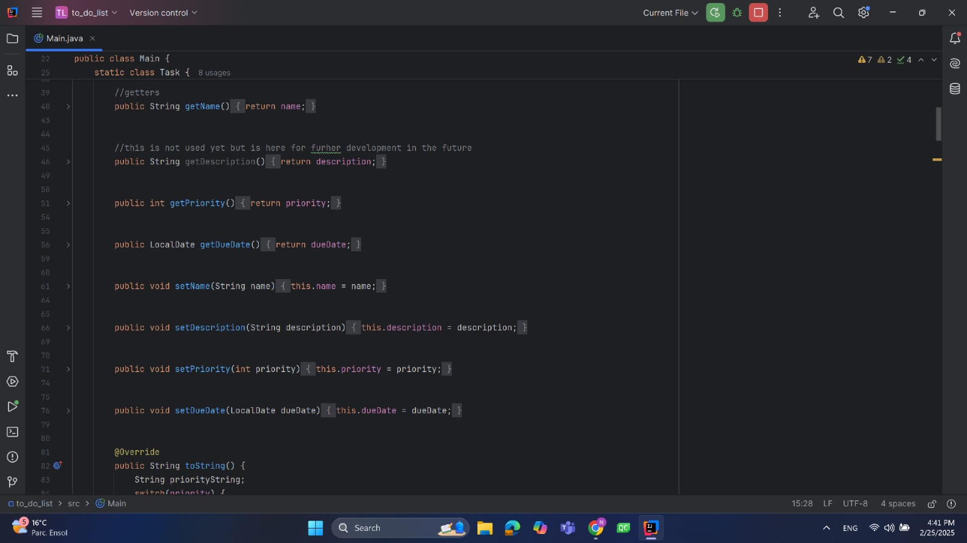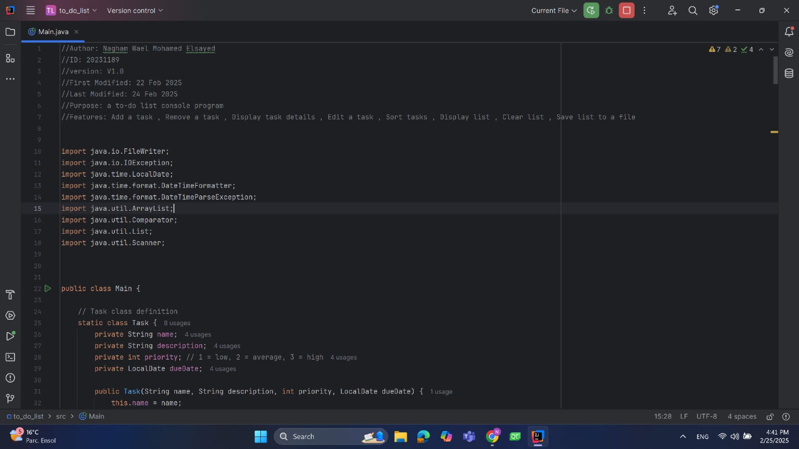

Video Link:

https://youtu.be/VqOBuBvfRiw?si=WCep92XFi12x7LnN

**Fatema El-Zhraa Ahmed:**

* Hours of Study:12 hours
* Source of Study : <https://www.youtube.com/playlist?list=PLCInYL3l2AajYlZGzU_LVrHdoouf8W6ZN>
* Main Code Logic:
* public boolean MainMenu(){  
    
   Scanner in = new Scanner(System.*in*);  
    
   if (*isFirst*)  
   manager=new ContactManager();  
    
    
   ArrayList<String> choices=new ArrayList<String>(Arrays.*asList*("1","2","3","4","5","6"));  
   String choice=check_menu("Choose from the following : \n\n1.Add a new contact\n2.Delete a contact\n3.Search for a contact\n4.View all contacts\n5.Save contacts in a file\n6.Exit\n\nEnter your answer : ",choices );  
    
    
   if(choice.equals("1")){//Add  
    
   boolean isRepeated=manager.Add();  
   if(!isRepeated)  
   System.*out*.println("Sorry , it will not be added for repeating phone number or email");  
   else  
   *isSaved*=false;  
    
   }  
   else if( choice.equals("2")){//Delete  
    
   if(manager.Delete())  
   *isSaved*=false;  
    
   }  
   else if( choice.equals("3")){//search for (by name , number)  
    
   ArrayList<String> Choices=new ArrayList<String>(Arrays.*asList*("1","2"));  
   String Choice =check_menu("you want to search by:\n1.phone number\n2.name\n\nEnter your choice : ",Choices);  
    
   if(Choice.equals("1")) {  
   contact person = manager.Search(true);  
   if(person!=null)  
   System.*out*.println(person.tostring());  
   else  
   System.*out*.printf("Sorry the contact is not found\n\n");  
    
   }  
   else {  
   contact person = manager.Search(false);  
   if(person!=null)  
   System.*out*.println(person.tostring());  
   else  
   System.*out*.printf("Sorry the contact is not found\n\n");  
    
   }  
    
   }  
   else if( choice.equals("4")){//view all contacts  
    
   manager.Display();  
    
   }  
   else if( choice.equals("5")){//Save contacts in file  
    
   if(!*isSaved*)  
   manager.Save();  
    
   *isSaved*=true;  
    
   }else{//Exit  
    
   if(!*isSaved*){  
    
   ArrayList<String>Choices=new ArrayList<String>(Arrays.*asList*("1","2"));  
   String Choice=check_menu("Do you want to save changes before exiting?\n1.Yes\n2.No\n\nEnter your choice : ",Choices);  
    
   if(Choice.equals("1"))// as task 5  
   manager.Save();  
    
   }  
    
   return false;  
   }  
    
   *isFirst*=false;  
   return true;  
    
  }

Screen Shots :

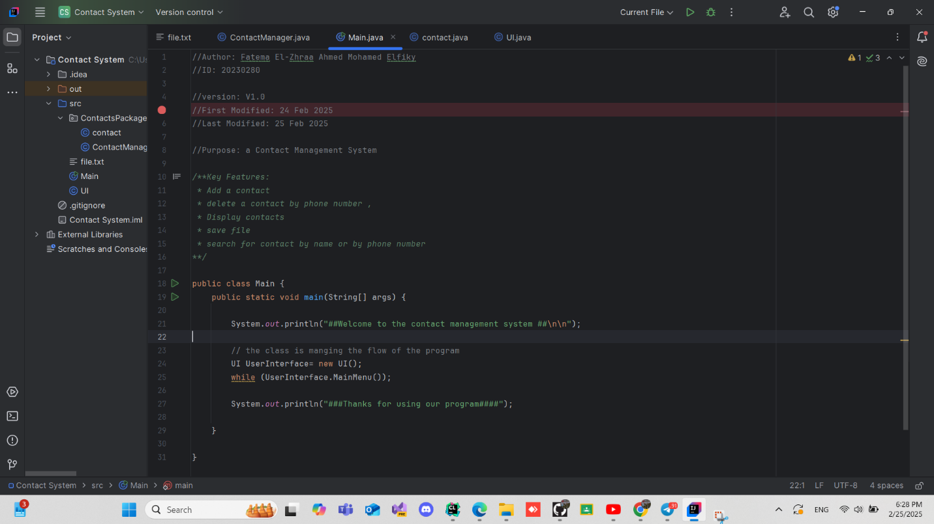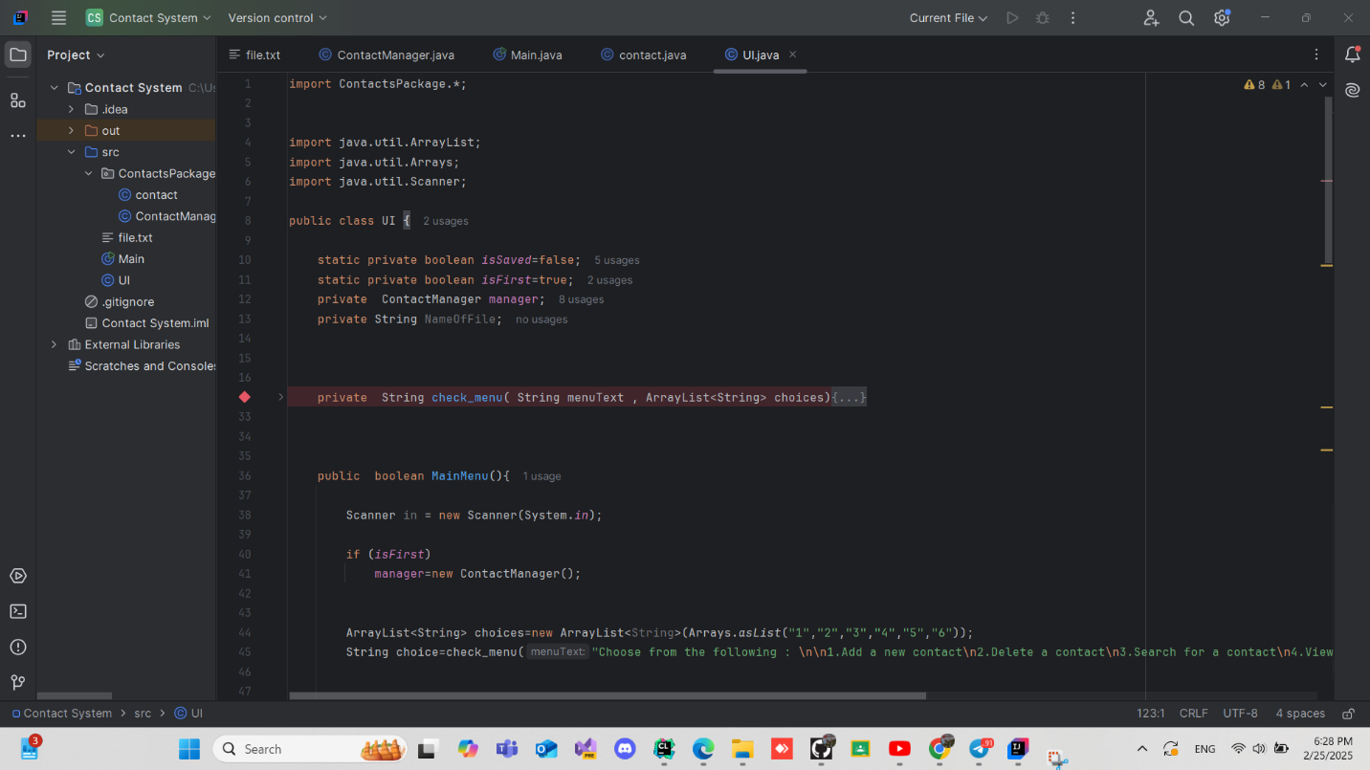

Video Link: <https://www.youtube.com/watch?v=fuV9C_FRDf8>

**Low-Code/No-Code (LCNC) Tools: Evaluation, Potential, and Impact**

**Evaluation of LCNC Tools:**

**As for Thunkable:**

Thunkable is a popular LCNC platform for building mobile applications with a visual drag-and-drop interface.

It allows users to create cross-platform iOS and Android apps without deep programming knowledge. While it excels in simplicity and rapid development, it has limitations in customization and performance for highly complex applications.

**As for Webflow:**

Webflow is a powerful LCNC tool for building responsive websites without writing code. It provides extensive design customization, CMS integration, and e-commerce capabilities.

However, for more advanced backend functionality, developers may still need to use custom code or external integrations.

**The potential of LCNC Tools:**

**As for Thunkable:**

Thunkable has great potential for facilitating mobile app development, particularly for non-developers and small businesses.

It enables rapid prototyping and deployment of functional mobile applications, making app development more accessible.

**As for Webflow:**

Webflow empowers designers and entrepreneurs to create sophisticated websites without relying on developers.

It is particularly useful for startups and businesses that require dynamic, responsive websites with CMS capabilities but lack coding expertise.

**What LCNC Tools Can Do:**

**As for Thunkable:**

* Create cross-platform mobile applications.
* Integrate APIs and external services.
* Implement UI/UX elements with a drag-and-drop editor.
* Directly publish apps to the Apple App Store and Google Play Store.

**As for Webflow:**

* Build highly customizable, responsive websites.
* Integrate CMS and e-commerce features.
* Use pre-built animations and interactions.
* Export clean HTML, CSS, and JavaScript for further customization.

**Benefits of LCNC Tools:**

**As for Thunkable:**

* Simplifies mobile app development.
* Reducing costs and time-to-market.
* Provides a user-friendly interface for non-technical users.
* Allows for quick prototyping and iteration.

**As for Webflow:**

* Enables high-quality web design without coding.
* Offers powerful customization and design flexibility.
* Integrates seamlessly with CMS and third-party tools.
* Generates clean and exportable code for further modifications.

**The Quality of the Systems They Produce:**

**As for Thunkable:**

Thunkable produces functional and user-friendly mobile applications suitable for MVPs, small business apps, and educational purposes.

However, apps developed with Thunkable may face performance and scalability challenges compared to those built with native development.

**As for Webflow:**

Webflow websites are visually stunning and optimized for performance. The platform ensures high-quality front-end development, but for complex backend functionalities, additional integrations or custom coding may be required.

**Will LCNC Tools Take the Jobs of Developers?**

**As for Thunkable:**

While Thunkable simplifies app development, it will not replace developers. Advanced mobile applications still require custom coding, optimization, and backend functionalities that LCNC tools cannot fully provide.

**As for Webflow:**

Webflow empowers designers and marketers to build and maintain websites without developers, but for highly dynamic and database-driven applications, developers are still essential. Webflow acts as a tool that enhances productivity rather than replacing professional developers.

**Comparison Between Two LCNC Tools:**

|  |  |  |
| --- | --- | --- |
| **Key of Compare** | **WebFlow** | **Thunkable** |
| **Purpose** | Website design and development | Mobile app development (iOS & Android) |
| **Target Users** | Designers, developers, and businesses looking to create responsive websites. | Individuals and businesses looking to create mobile apps without coding. |
| **Drag-and-Drop Interface** | Yes, for building websites visually | Yes, for building mobile apps using a block-based interface |
| **Export Code** | Can export HTML, CSS, and JavaScript | No direct code export; apps are built within Thunkable’s environment |
| **Use Cases** | Landing pages, business websites, e-commerce stores, blogs, and portfolios | Prototyping, MVPs, mobile app development for business, education, and personal projects |

Screenshot of LCNC Code :

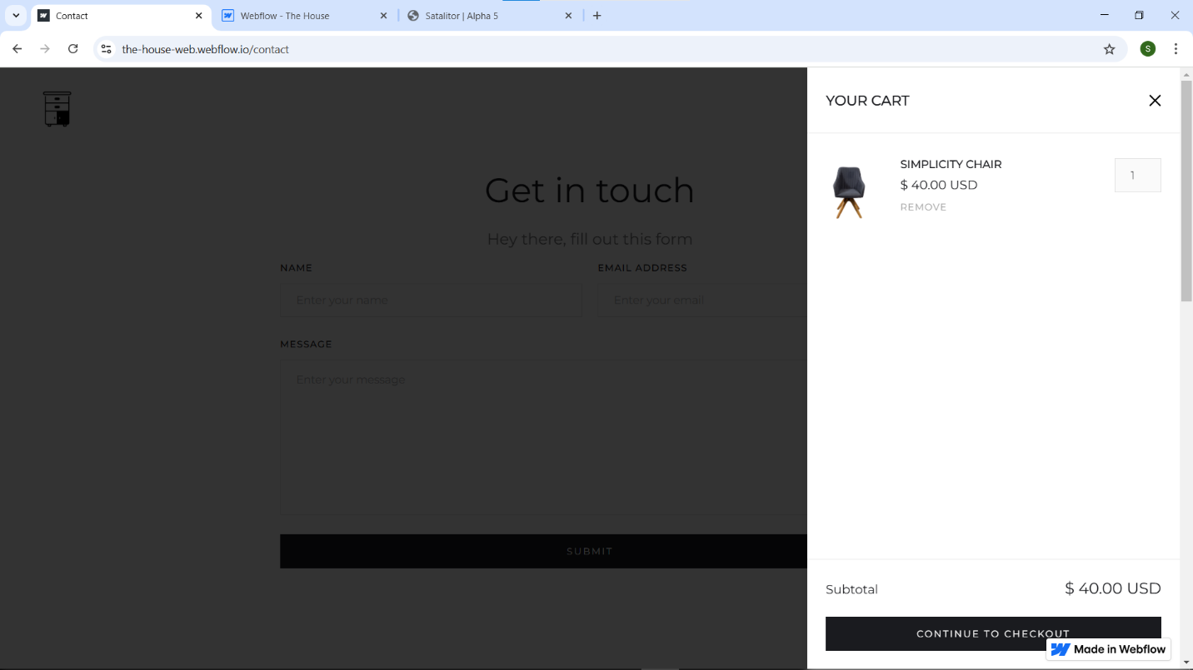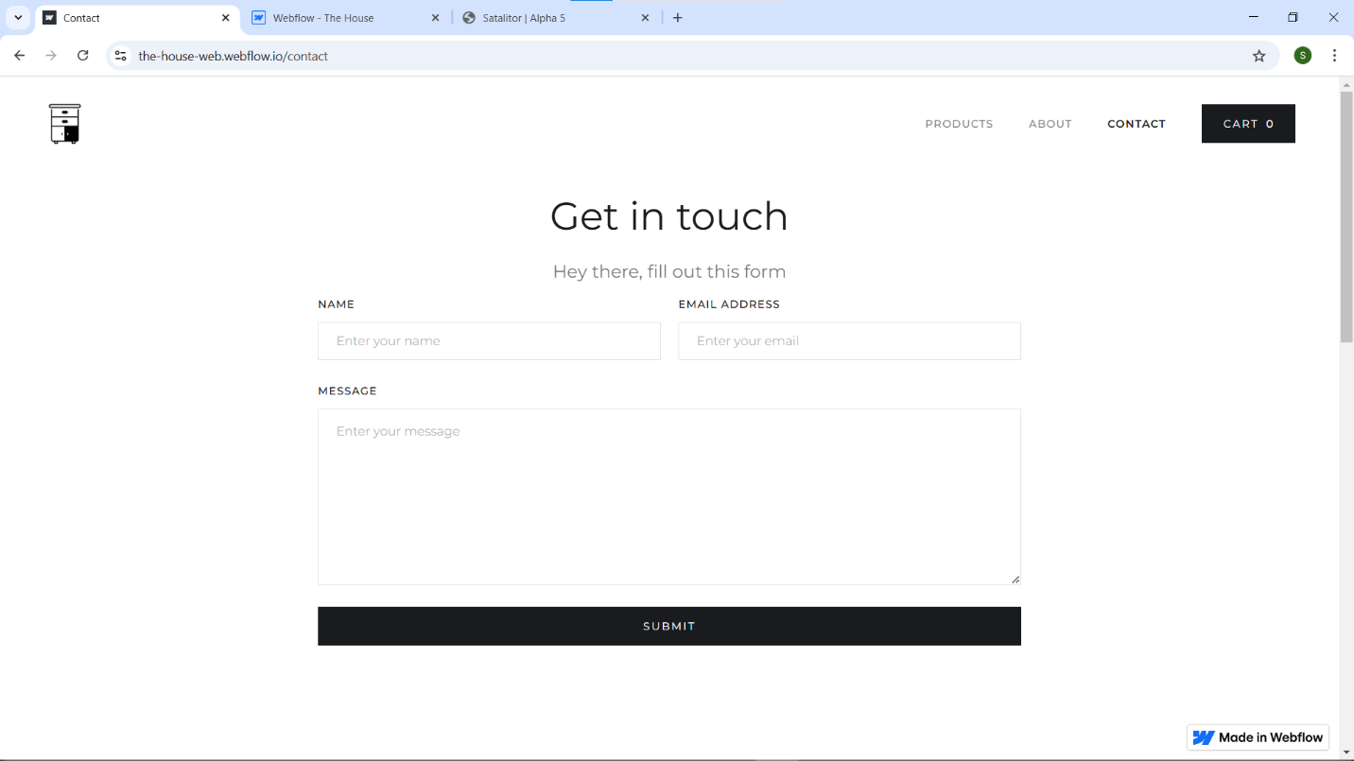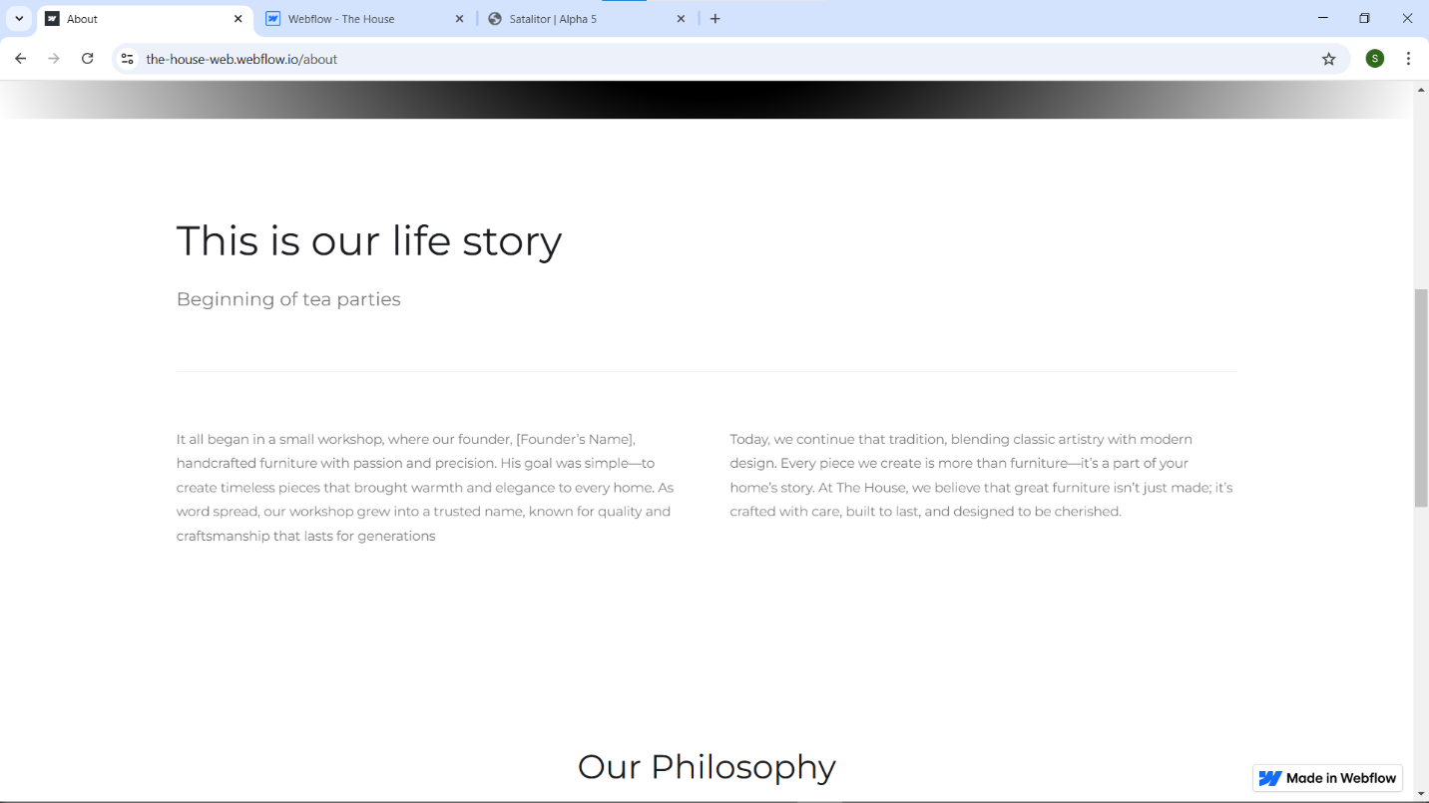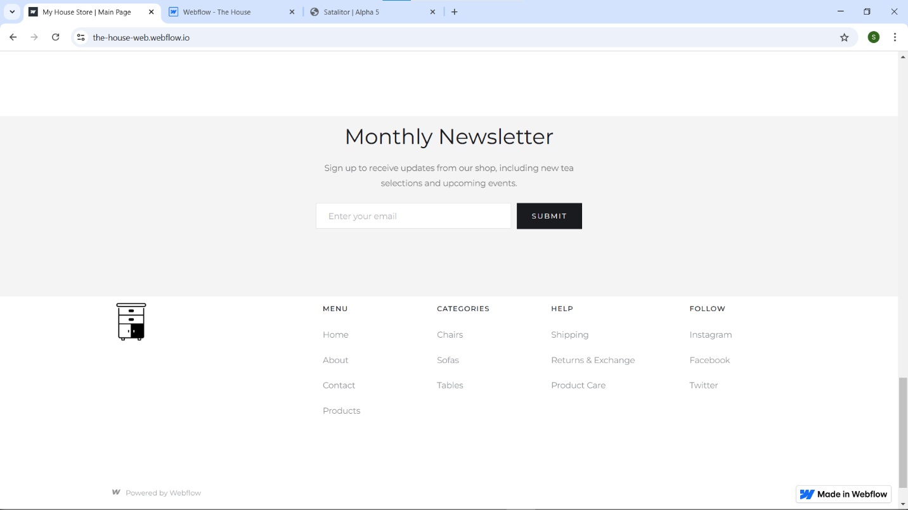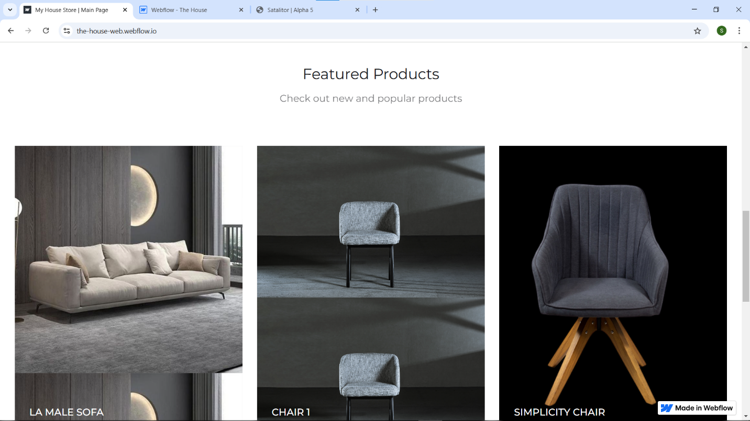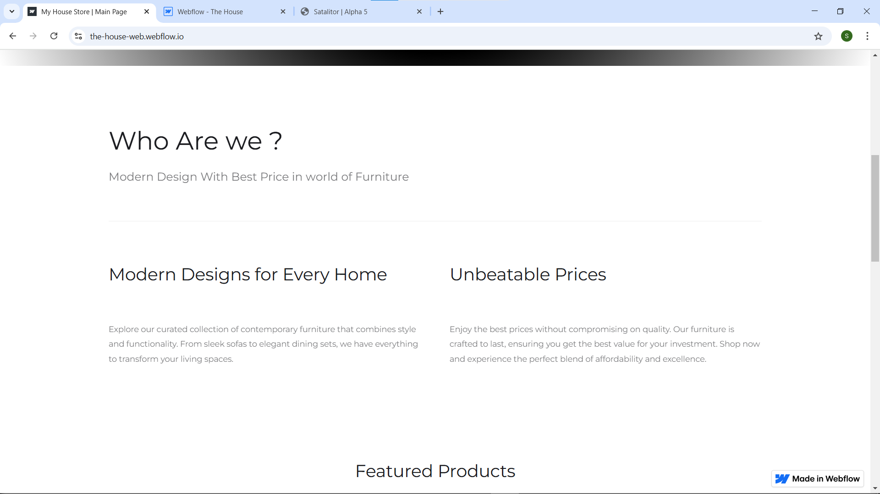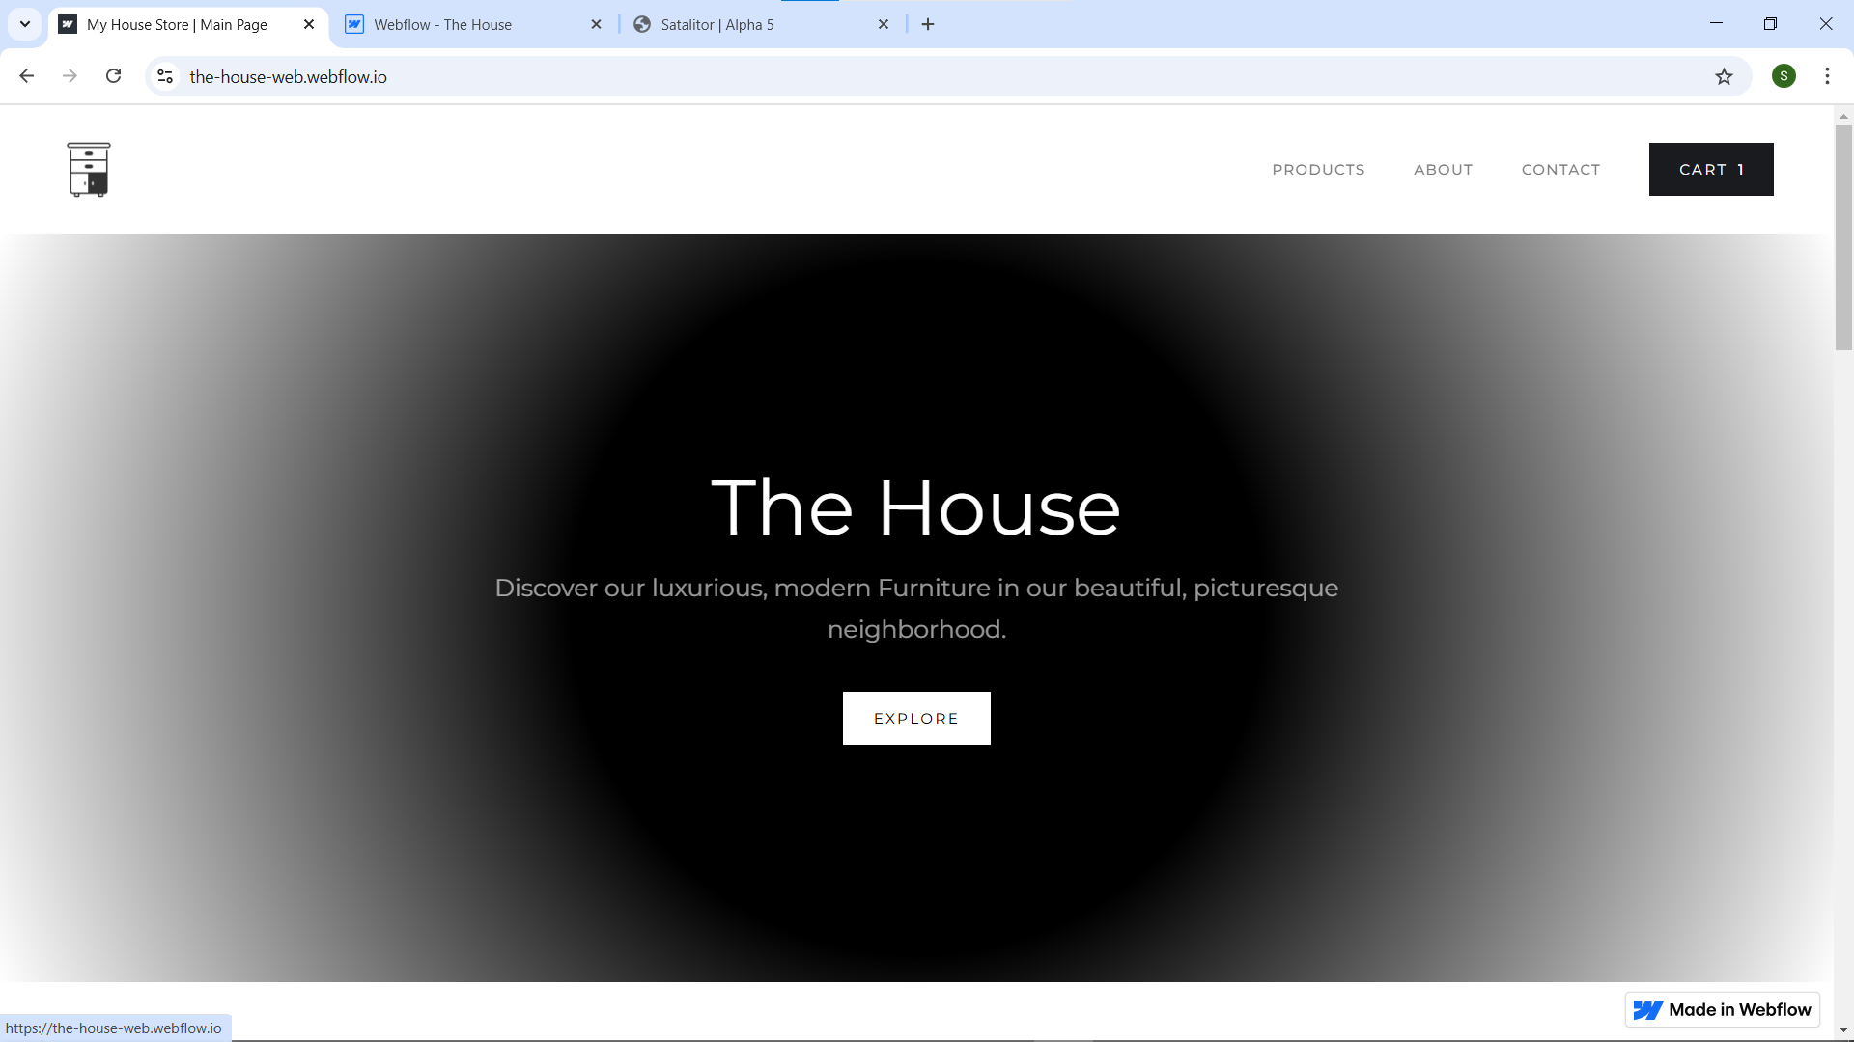

Website link: <https://the-house-web.webflow.io/products>

Video link:

https://youtu.be/c071WQAifNM?si=sWq_lknsMG3GbJbN

* Pre-Project Activities:

**Project Type: Personal Investment Management Software.**

1. **Market and Gap Analysis:**

**In Global Practices:**

Personal Investment management software is used widely all over the world, and it is most used in the United States and the United Kingdom. It has a lot of benefits that can help in your evolution, like:

Portfolio tracking consolidates financial data across various assets like stocks, real estate, and savings. This provides users with a clear overview of their investments.

Income tracking monitors revenue streams from different sources, such as salaries, dividends, and rental income. It helps users manage cash flow effectively.

Net worth calculation and ROI analysis compute overall financial standing by assessing assets and liabilities. This helps users track their wealth growth.

Visualization and graphs present financial data through interactive charts. These tools simplify performance analysis and trend identification.

Target setting allows users to establish financial goals, such as savings milestones or investment targets. It helps maintain a structured financial plan.

Risk and asset allocation analyzes portfolio risks and suggests diversification strategies. This ensures a balanced investment approach.

Bank and brokerage integration syncs financial institutions with the app. This enables real-time tracking of transactions and stock prices.

Not only that, but some of the international software are providing comprehensive financial solutions that can help the user and give the customer a better experience that help him in his problems, the solutions is not all the same each app has his own feature that categorize it from other apps

Providing detailed tracking of investments and retirement accounts. also by giving users insights into their financial health by analyzing assets, liabilities, and net worth, and one of the apps that is the best in this is Personal Capital.

Integrating budgeting with investment tracking, at the same time allowing users to set financial goals and track their progress effectively like what Mint does.

Focusing on automated investment management. helping in optimizing taxes, providing goal-based investing, and managing retirement planning, as one of the programs that do it is Wealthfront.

Specializing in commercial real estate investments, giving investors an easy way to track and manage their real estate portfolio like RealtyMogual.

Supporting a diverse range of assets, including stocks, bank accounts, cryptocurrencies, and real estate, makes it a versatile solution for investors like Kubera.

And a lot of other programs that have a lot of good features.

**In Egypt’s Market:**

Personal investment management software is gradually expanding in Egypt, though it is primarily focused on budgeting and stock trading rather than comprehensive wealth management. While global solutions dominate the market, Egyptian apps are emerging to meet local financial needs. These apps help users track their finances, but they often lack the full range of features found in international alternatives.

Stock trading platforms like Thndr provide users with access to the Egyptian stock market, allowing them to invest in and monitor their portfolios. However, they do not integrate real estate, crypto, or net worth tracking.

Budgeting tools such as Wafeer focus on expense management and savings tracking. These apps help users manage their day-to-day spending but do not offer full-fledged investment insights.

Financial services apps like FawryPay and ValU are primarily used for digital payments and consumer credit. While they offer convenience, they lack features for tracking diversified investment portfolios.

Brokerage platforms like Beltone Invest provide stock trading and investment services but do not consolidate different asset classes into a single dashboard.

Microfinancing solutions such as Halan cater to financial inclusion by offering small loans and credit services. However, they do not support wealth accumulation or investment tracking.

And it comes better day after day and not stop of there evolution but there is still a lack gap between the international programs and the Egyptian ones.

**Gap analysis:**

Egypt's investment management sector is growing, but it still lags behind international standards. While global apps offer comprehensive wealth management, Egyptian platforms mostly focus on budgeting and stock trading as:

Limited portfolio tracking prevents users from consolidating all their assets, such as stocks, real estate, and crypto, into a single dashboard. Weak investment analysis and ROI calculation mean most local apps prioritize transaction tracking over wealth growth insights.

Moreover, no Egyptian platform integrates multiple asset classes, such as brokerage accounts, real estate, and banking transactions, into one seamless experience. Minimal goal-setting and planning tools leave users without structured financial forecasting or retirement strategies. Underdeveloped visualization tools make it difficult to analyze financial trends effectively. Additionally, cryptocurrency investment tracking is almost nonexistent in local apps.

To close these gaps, an advanced Egyptian investment management app should offer full-scale asset tracking, AI-powered insights, financial goal-setting, and seamless integration with banks and brokerage services. By adopting these features, the market can move toward global standards, empowering users with smarter financial decisions.

1. **Global Market Analysis :**

**Customer Segments**

1. There are four major target audiences for personal investment management software around the globe:
2. **Millennials  (20-30 years old)**
   * Familiar with mobile applications and other fintech solutions.
   * Most probably early adopters of AI powered financial planning tools.
   * They seek investment information and saving towards a financial goal functionalities.
3. **Self-Directed Investors & Retail Traders**
   * Business owners who also self-manage their stocks, cryptocurrency, or real estate investments.
   * They require high level forecasting, risk evaluation, advanced analytics, and automation.
4. **Working & Middle Class Income Families**
   * Households looking for budgeting, saving, and investment solutions and probably have kids they spend money on.
   * They need family spending management, possible debt support, and comprehensive financial management.
5. **Financially Excluded & Underbanked Populations**
   * Large unbanked communities worldwide need digital solutions to access financial services.
   * Software investment platforms can provide financial inclusion.

**Demographics**

* **Age:** 20-45 years old.
* **Income Level:** Middle and upper-middle income; people looking to grow wealth or manage expenses.
* **Education:** Varies, Educated or financially naive but wanting to learn.
* **Tech Usage Patterns:**
  + Use smartphones a lot.
  + Prefer digital banking & fintech over traditional banks.
  + Comfortable with and trust AI-driven solutions.

**Market Trends & Opportunities**

* **Financial Inclusion:** a trend in fintech apps that target underbanked populations.
* **Digital-Only Finance Growth:** digital banks and mobile wallets witness rapid growth.
* **AI & Automation:** Personalized service and AI-powered solutions and strategies.
* **Regulatory Support:** Governments promoting digital payment and financial inclusion for those who are financially excluded.

**Egypt Market Analysis**

**Market Landscape & Challenges**

* **67% of the population is unbanked, operating only with cash transactions**.
* **The mobile penetration rate is high (110%) but the traditional banking sector is not implementing digitalization fast enough.**
* **12 banks have introduced mobile wallets**, which is evidence of a movement towards digital finance..
* **Government regulations encourage financial inclusion**, but legacy banks are slow to adapt.
* **Existing finance apps are not able to provide actionable features, like budgeting or expense tracking**.

**Customer Segments in Egypt**

1. **Unbanked & Underbanked Individuals**
   * Large segment unbanked and have no access to traditional banking services.
   * They need mobile-first solutions for saving, budgeting, and digital transactions.
2. **Young Professionals & Students (18-35 years old)**
   * **65% of Egypt’s population is under 35**, which makes them the most potential category to benefit from FinTechs.
   * Interested in financial planning, investment, and digital banking.
3. **Small Business Owners & Freelancers**
   * Lack of access to traditional corporate banking services is the main obstacle for emerging businesses when it comes to their financial management needs.
   * Prefer mobile apps for invoicing, expense tracking, and digital payments instead of traditional programs.
4. **Middle-Class Households**
   * They are seeking broader management tools that can help them in monitoring expenses, setting up saving plans, and tracking debts.
   * Need to be educated about personal finance support.

**Demographics in Egypt**

* **Age:** 18-40 years old.
* **Income Level:** Low to middle-income, with a growing sense of the importance of good money management.
* **Education Level:** Varies; but most of them require financial education.
* **Tech Usage Patterns:**
  + Intense mobile users; many of them use a variety of apps.
  + Growing confidince in fintech and digital wallets.

**Market Performance & Competition**

* **Top Personal Finance Apps in Egypt (Q2 2023 Data from Sensor Tower):**
  + *Cash Book – Daily Expenses* (Steady user growth, peak downloads at 2K/week).
  + *CashKateb (Cassbana B.V.)* (Largest active user base ~27K).
  + *المصاريف (Al-Masareef App)* (Strong revenue performance, peak $71/week).
  + *Income Expense* (Steady downloads, growing user base).
  + *SajalAlhisabat* (Fluctuating downloads, peak at 4.4K/week).

**Opportunities for a New Solution in Egypt**

1. **Mobile-First & AI-Driven Personal Finance Management**
   * Digital-only finance apps seem more profitable than unmoving traditional banks.
2. **Financial Literacy Features**
   * World Bank research (2014) has revealed that only 27% of adult people in Egypt are financially literate.
   * An app that gives users information on investing and budgeting through educational content (investment guides, budgeting tips) could be the factor that attracts users.
3. **Smart Budgeting & Investment Tools**
   * Most existing finance apps in Egypt lack actionable insights.
   * Opportunity to integrate AI-driven expense tracking, investment suggestions, and saving automation is a possible way to bring fintech tools to the next level.
4. **Government Support & Market Growth**
   * Egypt’s **software market to reach $498.36M by 2025**, with **CAGR of 8.93% (2025-2029)**.
   * Fintech startups can grow with the support for digital financial services.

**Conclusion: Why Would These Groups Use This Solution?**

* **Young professionals and students** → Essentially, they need technology-first, user-friendly financial platforms.
* **Unbanked & underbanked users** → They do not have access to traditional banking; however, mobile wallets may be an entry point.
* **Freelancers & small businesses** → They require financial management tools without the banks involved.
* **Middle-class households** → Require budgeting and expense tracking to manage financial goals.

**Final Insights**

* **Egypt has young, tech-interested population that is ready for fintech solutions.**
* **Traditional banks are slow to digitize, creating space for mobile-first apps.**
* **Existing apps lack deep insights and educational features, leaving a market gap.**
* **Government support for digital payments accelerates fintech adoption.**